Problem statement
International diners in the US often experience anxiety and decision fatigue when ordering food because traditional menus lack visual previews. This transforms what should be a relaxing cultural experience into a high-stress situation where they are unsure of what they are ordering.

Goal
The goal is to speed up their decision-making process and enable them to order with confidence. Transforming the anxious experience into a fast, clear, and easy one.

Process Overview
- Discover
  - Primary and Secondary Research
    - Validate the problem
    - Understand business implication
    - Identify feature/monetization opportunities
  - Competitive analysis
    - Identify opportunities/gaps
- Define
  - Customer segment
  - Features
- Design

Discover

Primary Research
I used survey to understand the current behavior and identify pain point.
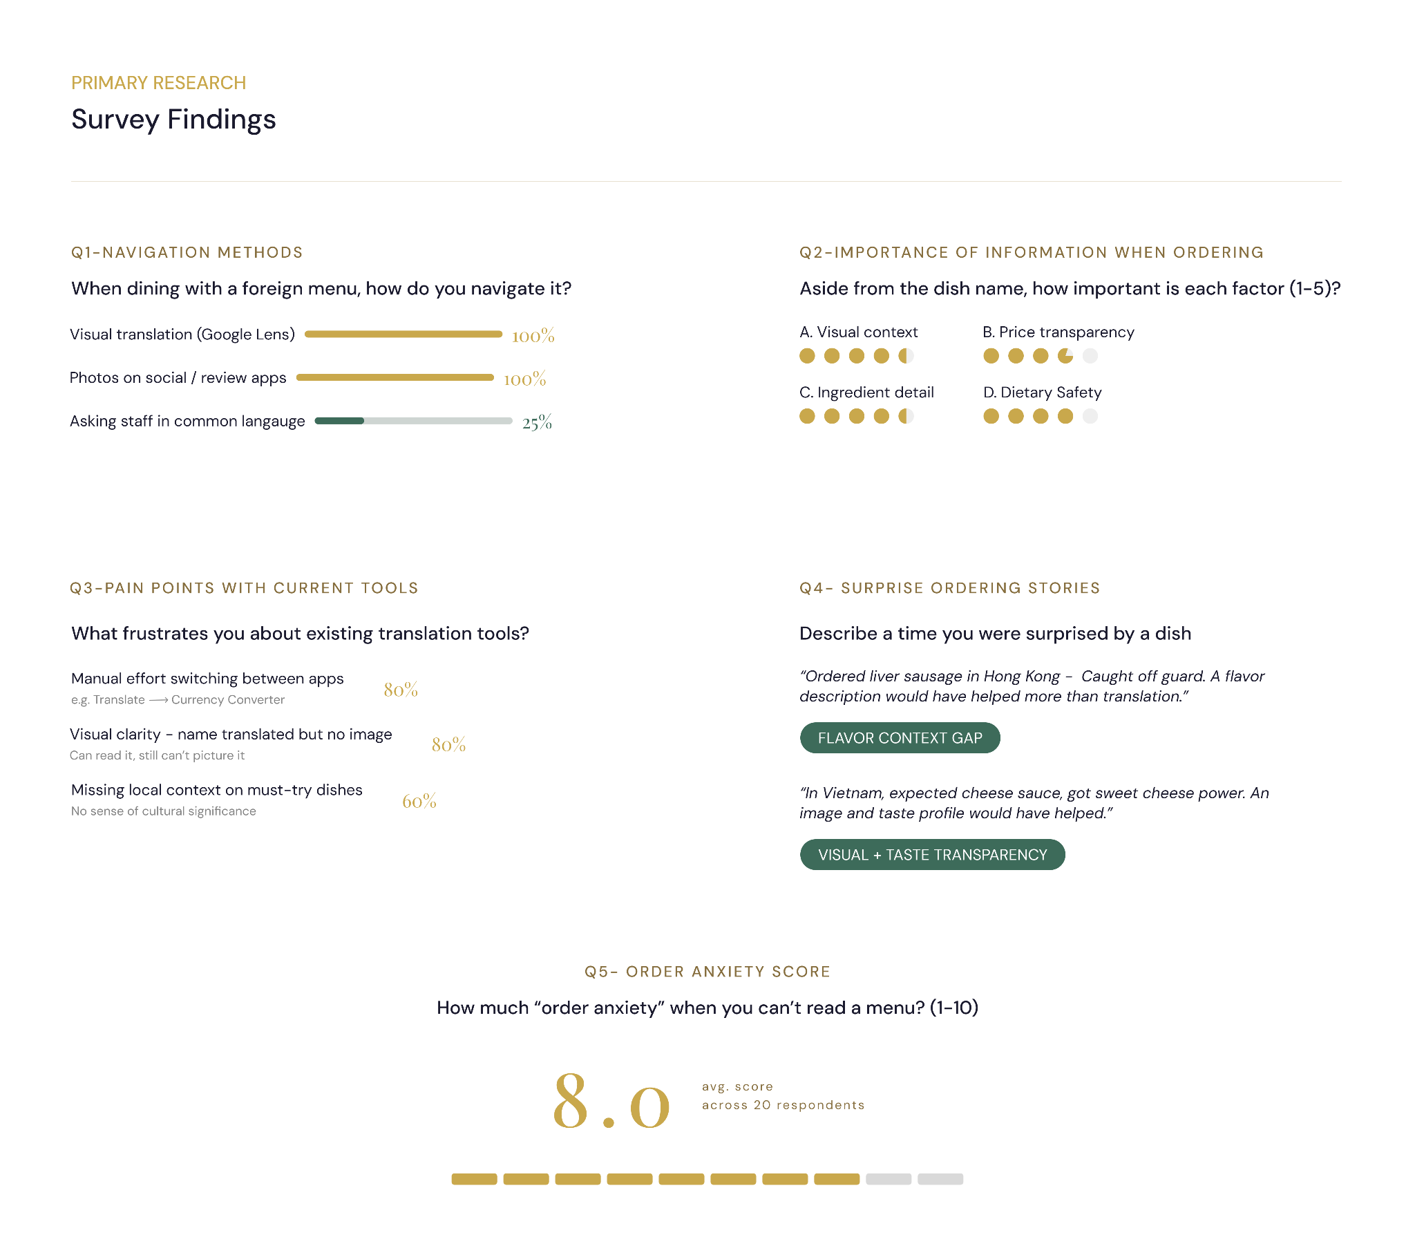
(Secondary research result)
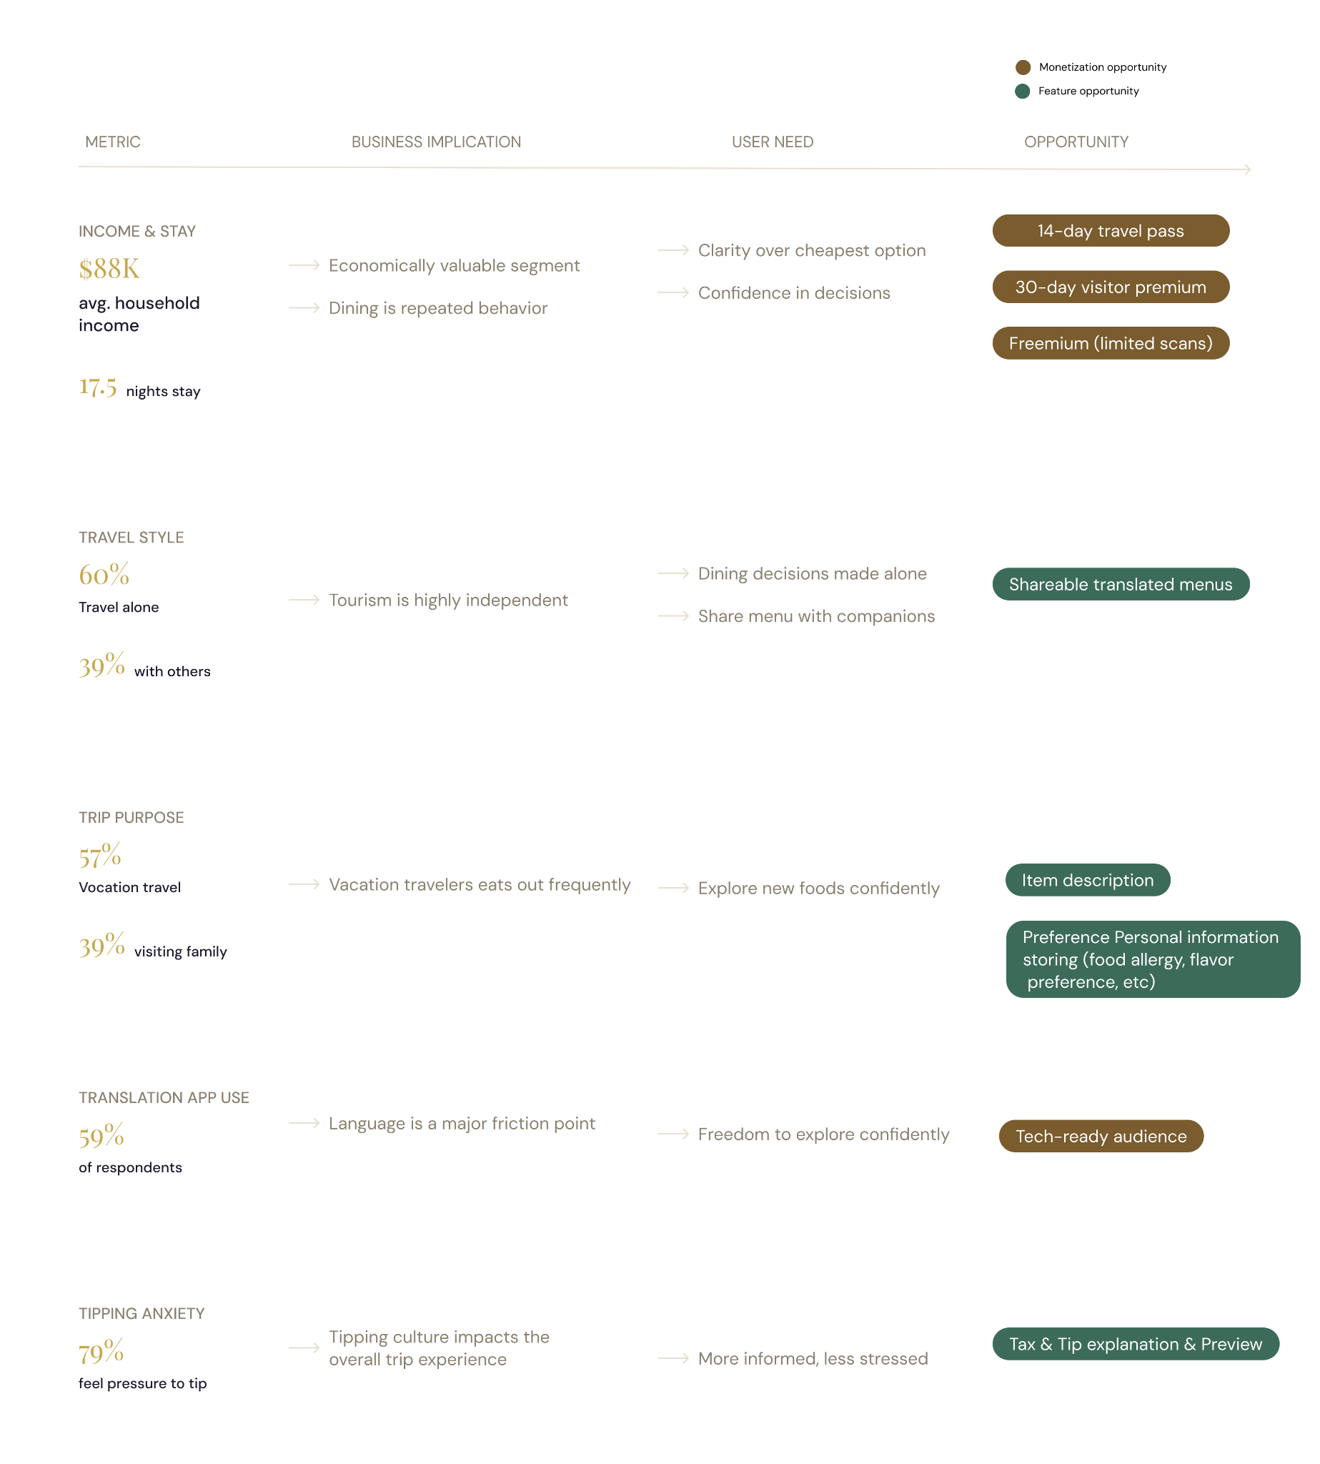

Define
Customer segment:
International visitors from non-English speaking regions with mid to high income who stay in the US for 15-30 days. They either travel alone or with partners. The primary users come to the US for vacation purposes.
Rationale:
1. Higher willingness to pay
- Tourists are already in "spending mode" — dining out is a core part of the vacation experience, not an everyday cost
they're trying to minimize
- The $88K income + 17.5 night stay data suggests they have budget for premium experiences

2. More acute pain point
- A tourist encounters unfamiliar menus intensely but briefly — every meal is a new challenge with no time to learn or adapt
- Immigrants and students gradually build familiarity over time, reducing their reliance on the tool
- Tourists never get that chance, so the problem stays acute every trip

3. Cleaner monetization
- A travel pass or trip-based subscription model is a natural fit — people are used to paying for travel apps
- Students and immigrants expect free tools (Google Translate, Yelp) and are harder to monetize

4. Existing secondary research still fully supports this
- You don't need to redo anything — the data you have is directly scoped to this segment

5. Focused scope is better for a first version
- Designing for tourists, students, and immigrants simultaneously means designing for three different contexts, budgets, and usage patterns
- Tourists alone is a well-defined, validated, monetizable starting point

---
In short — tourists are the segment where the pain is sharpest, the willingness to pay is highest, and your existing
research is strongest. It's a defensible choice.

Potential features enabling quick and confident decision:
- Image-first interface
- Inline ingredients, dietary & flavor context
- Preference-based menu highlights
- Tax & tip explanation & preview

Competitive Analysis (what’s out there)

Opportunities (How to stand out)

Design (the main user flow)

Next Steps

Learnings
- AI tools are helpful but judgement from designers is essential.
- Business thinking is required from the start.

